National Museum of Funeral History
415 Barren Springs Drive
Houston, Texas 77090
281-876-3063

MEDIA CONTACT:
Lydia Baehr
Lydia@LTBaehr.com

FOR IMMEDIATE RELEASE: JANUARY 22, 2020

National Museum of Funeral History reveals new exhibit,
George H.W. Bush Memorial Exhibit on President’s Day 2020

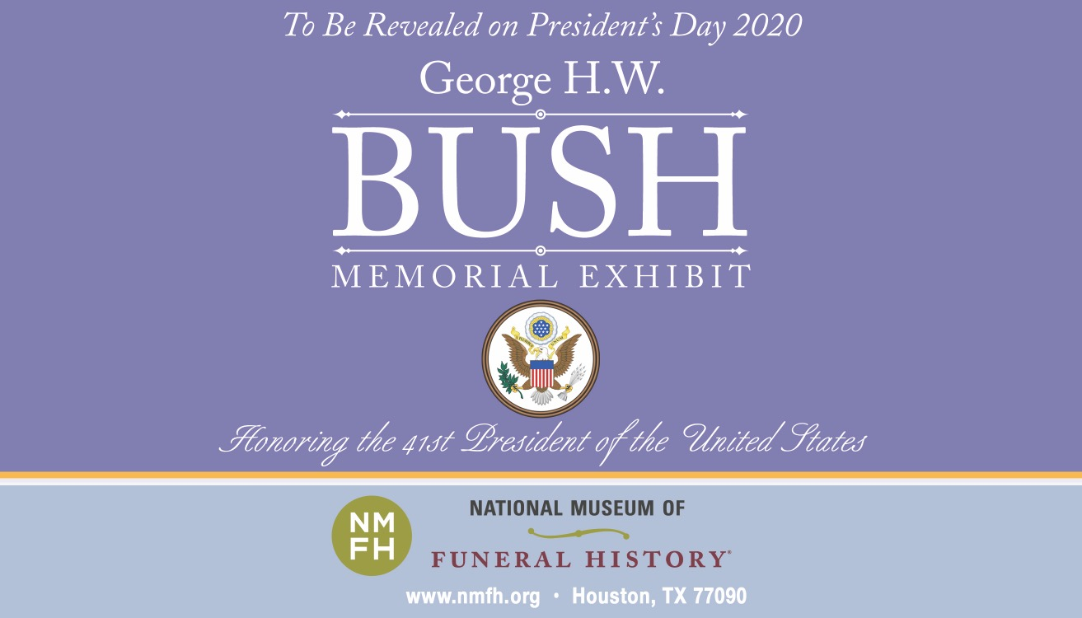

HOUSTON – Connect with key moments in U.S. history. The highly anticipated George H.W. Bush Memorial Exhibit, Honoring the 41st President of the United States, will be revealed on President’s Day, Monday, February 17, 2020.
“We are very excited and honored to be able to present this outstanding exhibit to the American people,” stated Bob Boetticher, Chairman of the National Museum of Funeral History.
The exhibit will focus on the lives of George and Barbara Bush, along with their funeral services as well as the now famous “4141” funeral train.
The exhibit includes many items such as the memorial folders and tribute cards from Washington, D.C. and Houston. The permanent exhibit also includes vestments worn by Rev. Dr. Russell J. Levenson, Jr. and the uniform of Navy Capt. Judy T. Malana, U.S. Navy Chaplain, both who presided at the funeral. More items to note are a copy of the script read by his granddaughters at the funeral, the presidential seal on the funeral train and the Union Pacific uniform worn by the train’s engineer, June Nobles.

Footage from “George H.W. Bush – His Final Journey,” from the Union Pacific West Lake Facility near Houston to A&M University in College Station will be on display. It includes footage of the arrival of the 4141 train, the “Aggie War Hymn” requested by George H.W. Bush that was played and the Texas A&M Corps of Cadets who lined the last leg of the motorcade’s journey. It features the military honors given, including the “Missing Man Formation” at the George H.W. Bush Presidential Library, the three volleys over the grave and a 21-gun salute and final presentation of the United States flag to President Bush’s daughter, Dorothy Bush Koch.

About the National Museum of Funeral History
Since 1992, the National Museum of Funeral History houses the country's largest collection of funeral service artifacts in 30,500 square feet of exhibit space and features 15 permanent exhibits on one of man’s oldest cultural customs.

Explore the largest funeral memorabilia collection from around the world. Discover the history of mourning rituals, vintage professional vehicles, authentic items from former U.S. Presidents and Papal funeral customs. Learn about the rich heritage of funeral services and much more.

The museum is located at 415 Barren Springs Dr., Houston, Texas 77090 and is open Monday – Friday from 10 a.m. – 4 p.m., Saturday from 10 a.m. – 5 p.m. and Sunday from 12– 5 p.m.

Admission is $10 for adults, $9 for seniors and veterans; $7 for children 6 – 11 years old; and free for children age 5 and younger. For more information, visit www.nmfh.org.

###

