Genevieve Keeney-Vazquez
President/Chief Executive Officer
National Museum of Funeral History

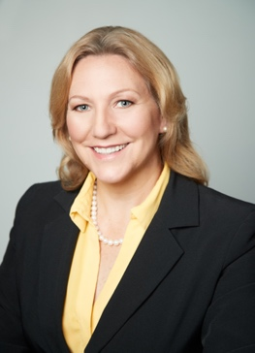

Genevieve Keeney-Vazquez is the President/CEO of the National Museum of Funeral History in Houston. The museum serves as an educational and cultural resource with an extensive array of permanent and changing exhibits. “Death is sure to happen to all of us, yet most of us don’t plan for it,” says Keeney-Vazquez. “The museum is a neutral place to ponder and discuss this guaranteed event in life, as well as explore the history of the industry.”

Keeney-Vazquez is a 12 year, US Army Veteran, holds a Master of Science in Nonprofit and Association Management and a Bachelor of Science in Psychology from the University of Maryland and an Associate’s Degree of Applied Science from Commonwealth Institute of Funeral Service. She is a Licensed Funeral Director/Embalmer in Texas and a board member for Commonwealth Institute of Funeral Services. Genevieve enjoys family time with her husband, 4 children, 7 grandchildren, parents and nephew. She enjoys spending time traveling with her husband and running marathons to explore the world and meet new people.

