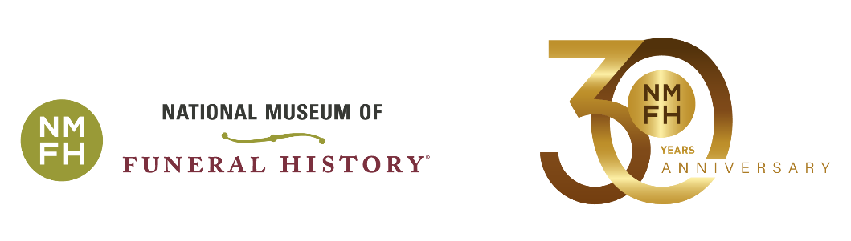

We are pleased to announce the National Museum of Funeral History’s 28th Annual Charity Golf Classic is scheduled on Monday, November 7, 2022 at 9:30 a.m. at Kingwood Country Club in Houston, Texas. We invite you to attend this five-man scramble tournament, which is an excellent opportunity to network with business executives and funeral industry professionals from across the country, as well as support the museum. In 2021, more than 75 sponsors and 330 players supported this charity event.

We also invite you to join us at the Sponsor Appreciation Night on November 6 from 5-7 p.m. at the National Museum of Funeral History complex. At the event, light hors d’oeuvres and complimentary cocktails will be served among the museum exhibits. Guests will have the opportunity to check-in early for the tournament, bid on the silent auction items and purchase mulligan tickets.

Honoring the compassion and dedication of the funeral industry has been the museum’s mission since it began in 1992. Today, the museum houses the nation’s largest collection of funeral artifacts and continues to enlighten visitors about the rich history of funeral service.

Please join us as the museum celebrates 30 years in operation. This year, we are excited to share with you our newest exhibit, *History of Post Mortem Photography*, which opened in November 2021. Enjoy a sneak peek at our upcoming exhibit, *The Most Famous Burial of all Time,* featuring a certified copy of the Shroud of Turin.

Your continued support ensures the growth and preservation of the museum as well as the development of educational programs and temporary exhibits. Enclosed you will find information outlining the sponsor opportunities and the timeline of events. **Confirm your sponsorship today and** **register for the tournament online at** [**www.nmfh.org**](http://www.nmfh.org) **by October 21, 2022. If you are unable to register online, please contact Lucy Gonzalez or Genevieve Keeney at 281-876-3063 for assistance**. **All contributions are tax deductible to the extent allowable by law.**

We appreciate your support and hope you can join us at the Charity Golf Classic and Sponsor Appreciation Night.

Sincerely,

Robert M. Boetticher, Sr. Genevieve G. Keeney

Chairman  President/CEO

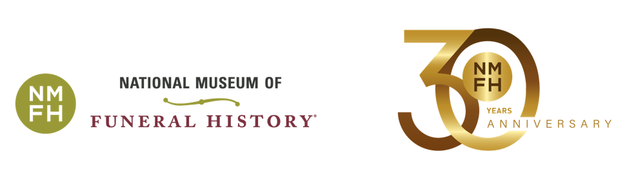

**Support the Museum: Become a Tournament Sponsor**

Want maximum visibility on the course? Consider becoming a Flag Sponsor. Pair it with another sponsor level to further boost your company’s presence at the tournament events.

**All contributions are tax deductible to the extent allowable by law. Register online at** [**www.nmfh.org**](http://www.nmfh.org) **by October 21, 2022.** **For additional information, contact Lucy Gonzalez or Genevieve Keeney at 281-876-3063.**

**Platinum Sponsor - $20,000**

* 10 player fees
* 4 guests to attend exclusive breakfast with museum executives
* Company name on banner displayed at all tournament events
* Merchandise voucher for each player

**Gold Sponsor - $15,000**

* 15 player fees
* Company name on banner displayed at all tournament events
* Merchandise voucher for each player

**Silver Sponsor - $10,000**

* 10 player fees
* Company name on banner displayed at all tournament events
* Merchandise voucher for each player

**Bronze Sponsor - $6,000**

* 5 player fees
* Company name on banner displayed at all tournament events
* Merchandise voucher for each player

**Golf Cart Sponsor (1 available) - $6,000**

* Company name displayed on sign in each golf cart

**Flag Sponsor (18 available) - $5,000 C:\Users\keeneygg\AppData\Local\Microsoft\Windows\Temporary Internet Files\Content.IE5\AV2A9I9Z\70px-Yellow_flag_waving.svg[1].png**

* Company logo on flag attached to flagstick and displayed at a green on each course
* Framed commemorative flag

**Beverage Cart Sponsor (3 available) - $5,000**

* Company name on sign displayed at beverage rest stops and one beverage cart per course

**Longest Drive Sponsor - $3,500**

* Company name on sign displayed at the long drive hole on each course

**Closest to the Pin Sponsor - $3,500**

* Company name on sign displayed at the closest to the pin hole on each course

**Driving Range Sponsor - $3,500**

* ****Company name on sign displayed at practice areas

**Team of Five Sponsor - $2,500**

* 5 player fees
* Merchandise voucher for each player

**Course Sponsor - $2,000**

* Company name on individual sign displayed on each course

**Friend of the Museum - Donations < $1,000**

* Company name on sign displayed at check-in

**Individual Player - $600**

* 1 player fee
* Merchandise voucher

**Ride Along - $325**

* Half golf cart, lunch & post tournament award reception
* Merchandise voucher

**Golf Club Rentals - $200**

*Credit card payment due at time of request. Two-week cancellation notice required for full refund.*

**Post Tournament Award Reception Only - $50**

* Meal at Kingwood Country Club

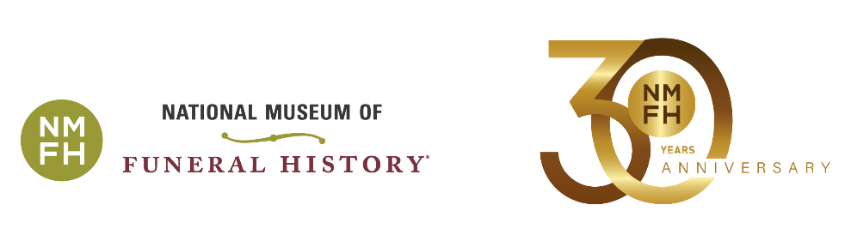

**2022 Timeline of Events**

**Friday, October 21 – Registration Deadline**

Register for the tournament online at [www.nmfh.org](http://www.nmfh.org).If you are unable to register online, contact **Lucy Gonzalez or Genevieve Keeney at 281-876-3063 for assistance.**

**Sunday, November 6 – Sponsor Appreciation Night**

*National Museum of Funeral History / 415 Barren Springs Drive, Houston, TX*

5:00 - 7:00 p.m. Early player check-in for the tournament

Enjoy complimentary cocktails and light hors d’oeuvres

Bid on silent auction items

View the latest exhibits to see how your donations impact the museum

**Monday, November 7 – Charity Golf Classic Tournament**

*Kingwood Country Club / 1700 Lake Kingwood Trail, Humble, TX*

7:30 a.m. Player check-in and merchandise voucher pick-up opens

Enjoy light continental breakfast

Exclusive Platinum Sponsor breakfast begins

9:30 a.m. Shot-gun start *(lunch available on course)*

3:00 p.m. Deadline to turn in scorecards

3:30 p.m. Post-tournament award reception and meal

5:00 p.m. Deadline to use merchandise voucher